JUDD’S MOTOR ZONE – PAGE TEMPLATE DESIGN
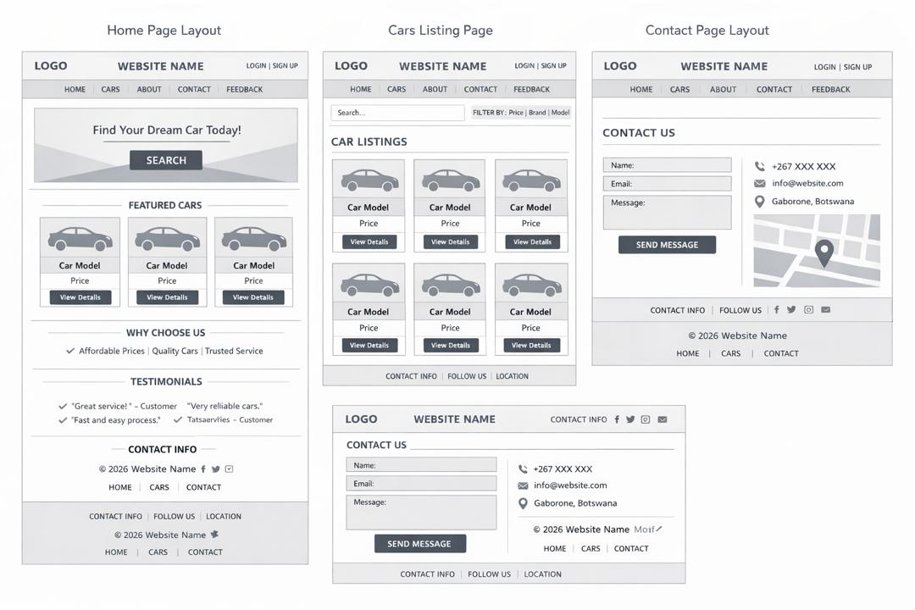
Figure 1: Wireframe layouts for Home Page, Cars Listing Page, and Contact Page.

